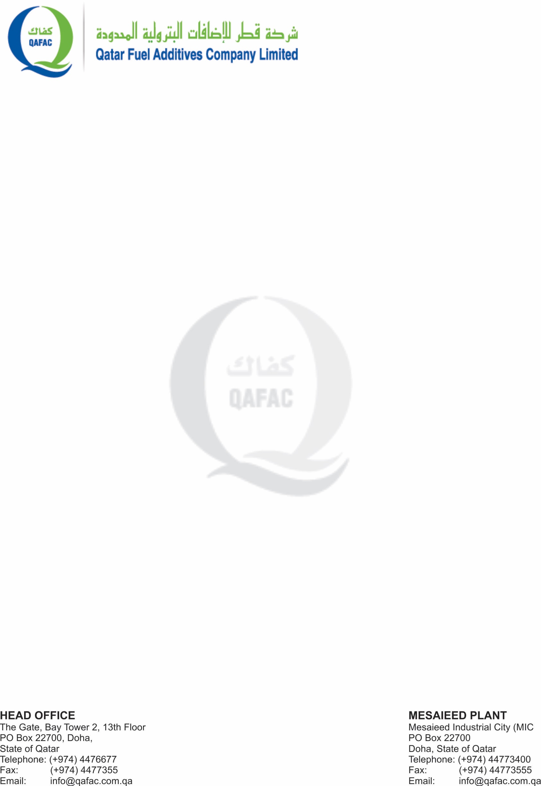

**TO WHOM IT MAY CONCERN**

We are pleased to write this letter that the applicant named <Name> had been working for us, Qatar Fuel Additives Company Limited, in his capacity as <Designation> from <From> to <To>.

During his tenure with our Organization, he participated in performing the work with determination and sincerity. As we observed, he was an active and very qualified person and he could perform all of assigned tasks effectively. Besides, in my opinion, he was a motivated, devoted, professional, hard-working, and innovative person. He contributed much to our organizational goals and targets and his performance was proven to be among the most effective in our organization.

Moreover, Mr. <Name> demonstrated excellent behavior and attitude during his/her service with us. We found him/her be sincere, truthful, reliable sociable. He/she was also a pleasant person to talk and work within a team. however, we still hope she will succeed in any path of career.

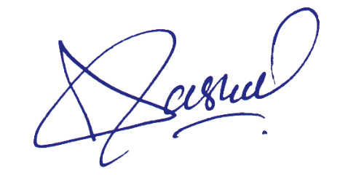

**ADAM BIN SAUL**

**PROJECT MANAGER**